Dream home assignment – Tomer Schwartz
Part 1

  - LangChain is an open-source application framework applied on top of existing LLM APIs, it includes standardized building blocks for LLM application development. Includes, prompts, toolchains, agent implementation, etc
  - LanGraph is also open-source and it essentially a state-machine plugin into langchain that allows expression of LLM workflows as directed graphs. It allows for multi agent orchestration, complex branching logic and synchronous and asynchronous logic.
- Pros:
The use of these frameworks allows for clean and standardized development without the need for implementing API usage directly on new projects, They have a very significant amount of LLMs that are already supported, have an active community which leads to quick updates and useful support. Initial development using these frameworks is much faster than implementing from scratch which allows for quicker POCs.
Cons: In large projects like these there is usually some dependency bloat which can impact performance. Updates can break previous work. These kinds of frameworks can be limiting to the developerwhen fine control is needed and the required control is not implemented. Huge projects can have significant security issues

  - RAG is a solution that addresses the significant limitation of LLMs which is the requirement for retraining of models to integrate new information. Retraining is exceedingly costly and time consuming, which would make smaller companies unable to afford usage. RAG uses external sources (vector stores, DBs, search engines, etc) to retrieve query relevant information and integrate it into the generation prompt given to the LLM.
  - The stages include:
    - Raw source collection: Document collection, web crawlers, news sources, etc)
    - Pre processing of the documents if necessary to fit a standardized format
    - Chunking for efficiency and to fit model limitations
    - Embedding and storing the information in appropriate vector store index (or alternative)
    - Retrival based on vector distance or other ranking/filtering properties
    - Prompt insertion based on prompt format and answer generation
    - Post processing if required
    - Evaluation/ feedback loops

Part 2:

As the first step it is important to understand the attack/technique we want to detect. A good place to start is the MITRE technique which gives an overview of the attack as well as known mitigation and detection solutions.
I then follow up to some of the references, usually based on how focused or recent they are. After understanding the landscape more and gathering possible detectable features.
I would next explore available data sources, composing possible detection rules on real world data as a first overview. If no such data exists, I would set up a lab environment to gather the data.
Following the initial exploration I would create the rule/s that showed the most promise, and make sure they pass the system performance tests or any other CI/CD required test.
Ideally the rules will first be deployed as silent or low severity alerts for real world performance analysis. Following a performance review the rules are approved or rewritten.

The golden ticket rule is in the attached YAML file (It was not validated, for syntax, I assume its meant for research thought process evaluation)

Part 3:
I updated the sigma agent by adding additional tools to access MITRE to extract technique info, detection ideas and deeper research using the provided external resources using beatifulsoup and async retrieval ( A lot of the links in the mitre data were out of date which caused a lot of retrieval faliures, but I think my intent is sufficiently shown in the work). To do that I added another vector store that embeds MITRE attack technique data. I also added the rule_chat.py script for the interactive rule creation chat which importantly has a memory to be able to do iterative improvements.

Updated/new files:
SigmAIQ/sigmaiq/llm/toolkits/base.py
SigmAIQ/sigmaiq/llm/toolkits/sigma_toolkit.py
SigmAIQ/sigmaiq/llm/tools/mitre_search_tool.py
SigmAIQ/sigmaiq/llm/base.py
SigmAIQ/rule_chat.py
SigmAIQ/sigmaiq/llm/toolkits/prompts.py
SigmAIQ/tomer_requirements.txt

As a next step I would like to implement internal feedback loops for the agnet to ensure consistent and valuable results. Using instructions like what was presented in the attached video: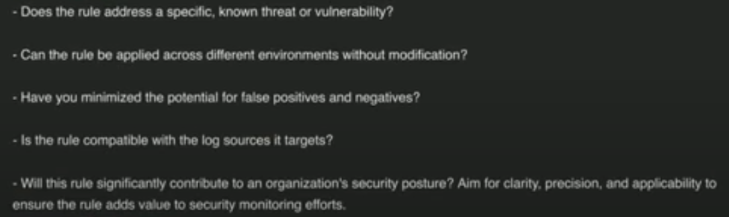

A more precise workflow with detailed decision trees would also be an important step to achieve better and more consistent results

Part 4:
For evaluation and benchmarking I would implement multiple steps.
- I would validate that the rule is formatted properly and doesn’t have any syntax errors or field mapping issues with the log sources used.
- Analysis of readability, explainability and known issues using external LLMs
- I would compare it with existing rules to make sure it isn’t overed or has too much of an overlap with existing rules. If it is completely covered it is probably not needed and if only partially it can be refined.
- Using a lab environment with ideally known expected results for the rule I would execute the rule and validate the results compared to the expected output. An expected Accuracy can be calculated if the data is robust. A simulation can also be run on generated data to increase the coverage of the testing. This can also be used for system performance evaluation
- If the rule passes initial QA testing and is deployed, I would try to use client alerts and feedback to validate the results, either with an initial “silent” rule that is invisible to clients or follow ups/triggers on significant FP reporting from clients.
The main criteria I would use to determine if a rule is good or bad would be:
- Completeness and structure:
  - Valid YAML formatting and syntax
  - Uses the appropriate log source fields
  - All metadata fields are filled
- Detection Accuracy:
  - Detects the expected activity with minimal overlap
  - Minimal FP FN
  - Sufficient detection metrics in testing and over time
- Avoid known pitfalls:
  - Avoids overly generalized queries
  - Uses Relationships between fields that make contextual sense
  - Try to identify overfitting to specific environments
- Explainability and readability:
  - Ensure the rule is human readable
  - Ensure the description is logical and sound

